PROBABILITY
Pearson Edexcel - Tuesday 19 May 2020 - Paper 1 (Non-Calculator) Foundation Tier

Pearson Edexcel - Monday 8 June 2020 - Paper 3 (Calculator) Foundation Tier

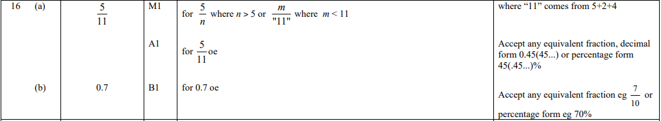

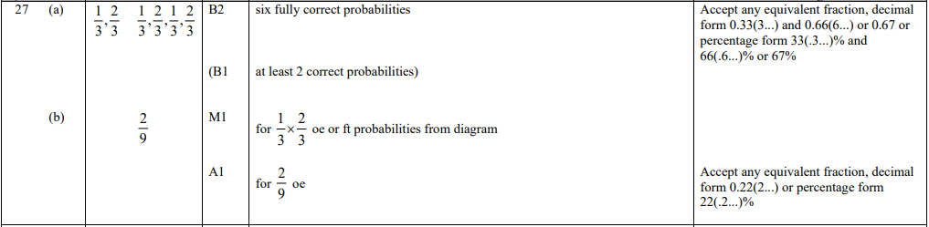

Pearson Edexcel - Tuesday 21 May 2019 - Paper 1 (Non-Calculator) Foundation Tier

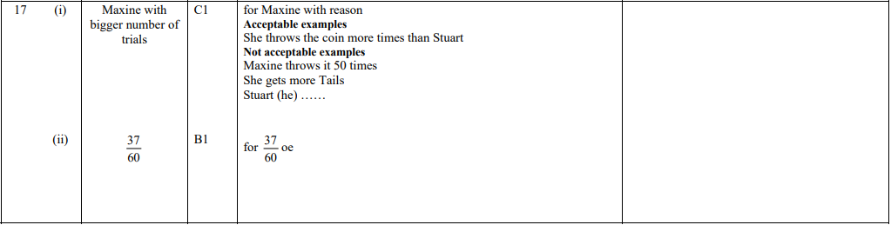
Pearson Edexcel - Thursday 8 November 2018 - Paper 2 (Calculator) Foundation Tier

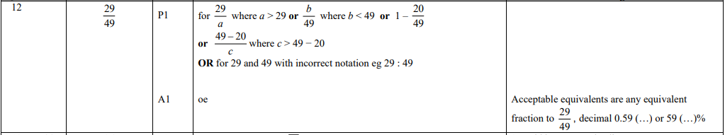

Pearson Edexcel - Monday 12 November 2018 - Paper 3 (Calculator) Foundation Tier

Pearson Edexcel - Monday 12 November 2018 - Paper 3 (Calculator) Foundation Tier

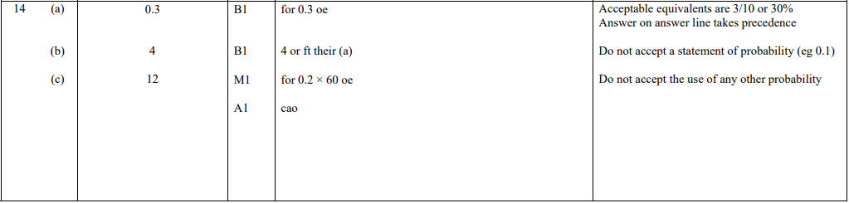

Pearson Edexcel - Thursday 24 May 2018 - Paper 1 (Non-Calculator) Foundation Tier

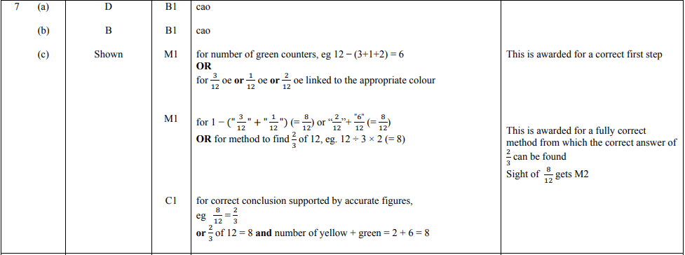
Pearson Edexcel - Thursday 7 June 2018 - Paper 2 (Calculator) Foundation Tier

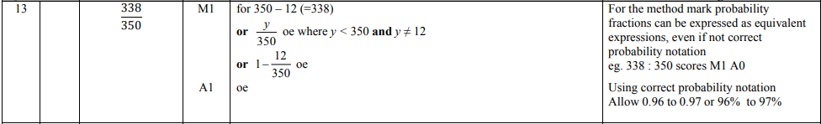

Pearson Edexcel - Thursday 2 November 2017 - Paper 1 (Non-Calculator) Foundation Tier

Pearson Edexcel – Specimen 2 - Paper 1 (Non-Calculator) Foundation Tier

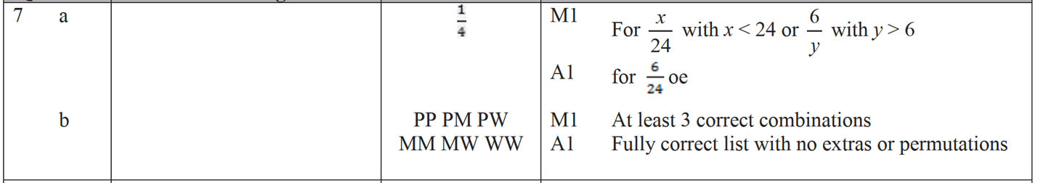

Pearson Edexcel – Specimen 2 - Paper 2 (Calculator) Foundation Tier

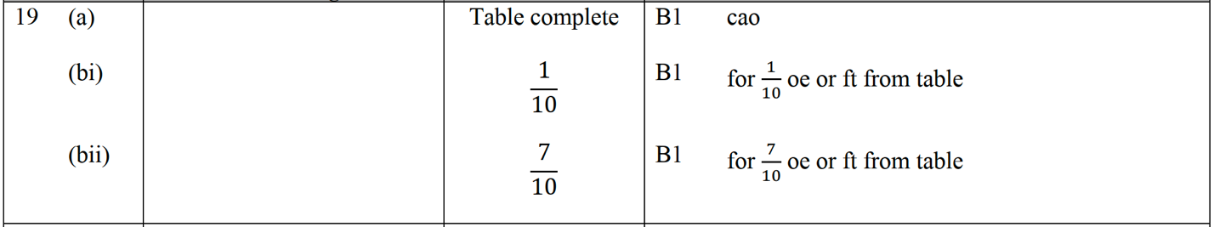

Pearson Edexcel – Specimen 1 - Paper 2 (Calculator) Foundation Tier

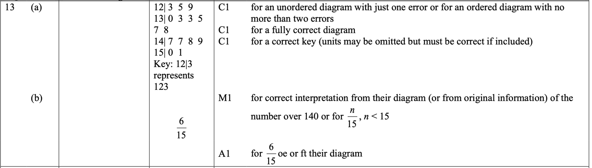

Pearson Edexcel – Sample Paper 1 (Non-Calculator) Foundation Tier

Pearson Edexcel – Sample Paper 1 (Non-Calculator) Foundation Tier

Pearson Edexcel – Sample Paper 1 (Non-Calculator) Foundation Tier

OCR – Tuesday 03 November 2020- Morning - Paper 1 (Calculator) Foundation Tier

OCR Thursday 05 November 2020- Morning (Non-Calculator) Foundation Tier
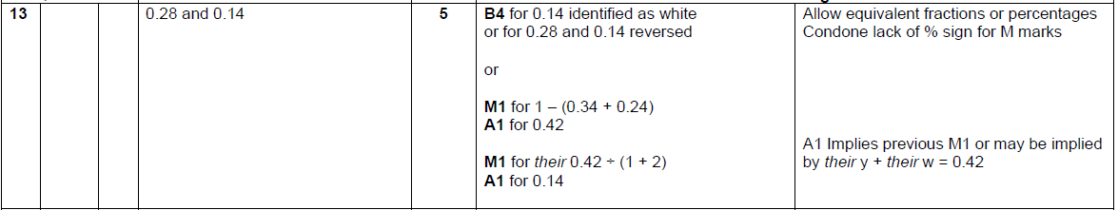

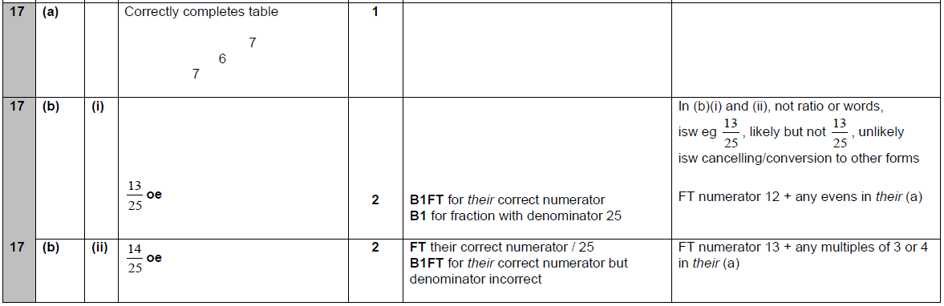

OCR Tuesday 5 November 2019 – Morning (Calculator) Foundation Tier
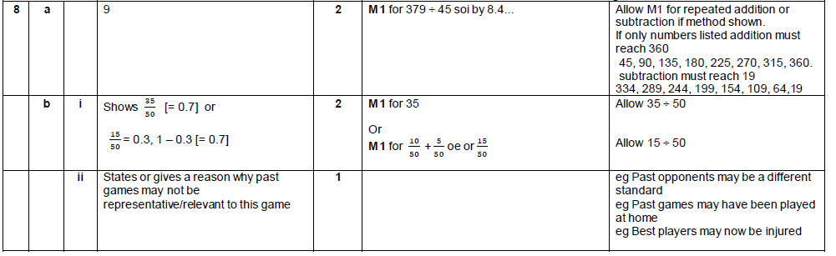

OCR Tuesday 21 May 2019 – Morning (Calculator) Foundation Tier

OCR Thursday 8 November 2018 – Morning (Non-Calculator) Foundation Tier

OCR Monday 12 November 2018 – Morning (Calculator) Foundation Tier
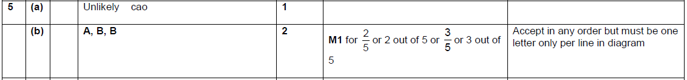

OCR Thursday 7 June 2018 – Morning (Non Calculator) Foundation Tier
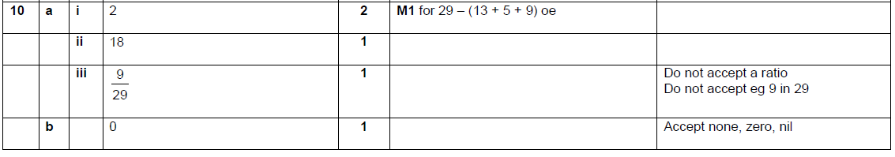

OCR Tuesday 12 June 2018– Morning (Calculator) Foundation Tier
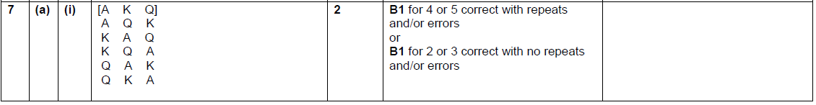

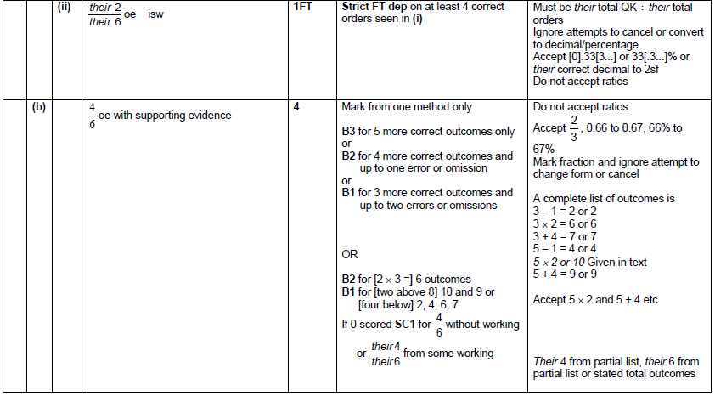

OCR Thursday 2 November 2017– Morning (Calculator) Foundation Tier

OCR Monday 6 November 2017– Morning (Calculator) Foundation Tier

Pearson Edexcel – Sample Papers - Paper 1 (Non-Calculator) Foundation Tier

Pearson Edexcel –Sample Papers - Paper 2 (Calculator) Foundation Tier

Pearson Edexcel – Sample Papers - Paper 3 (Calculator) Foundation Tier

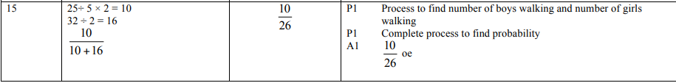

OCR Sample Question Paper 3 – Morning/Afternoon (Calculator) Foundation Tier

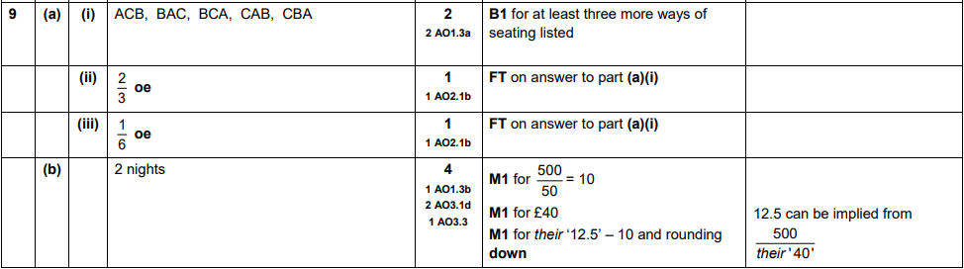

AQA Tuesday 19 May 2020 – Morning (Non-Calculator) Foundation Tier

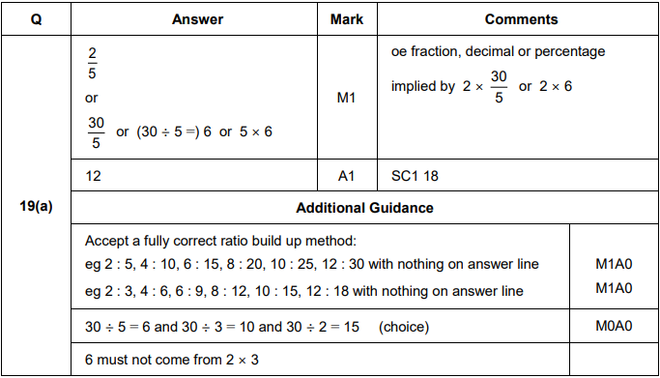
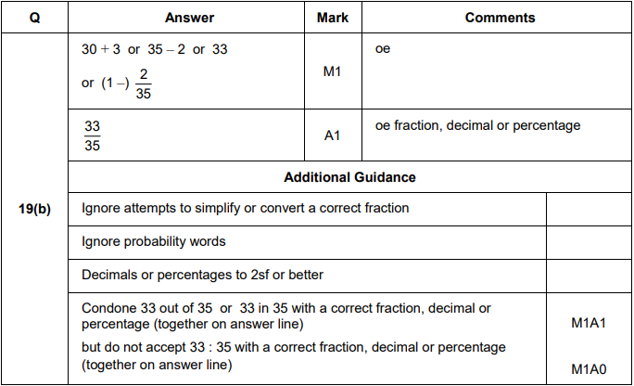

AQA Tuesday 6 November 2018 – Morning (Non-Calculator) Foundation Tier

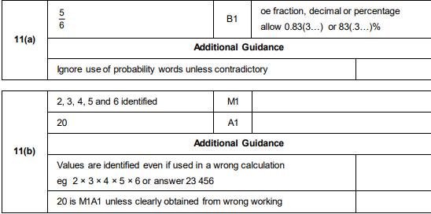
AQA Tuesday 6 November 2018 – Morning (Non-Calculator) Foundation Tier

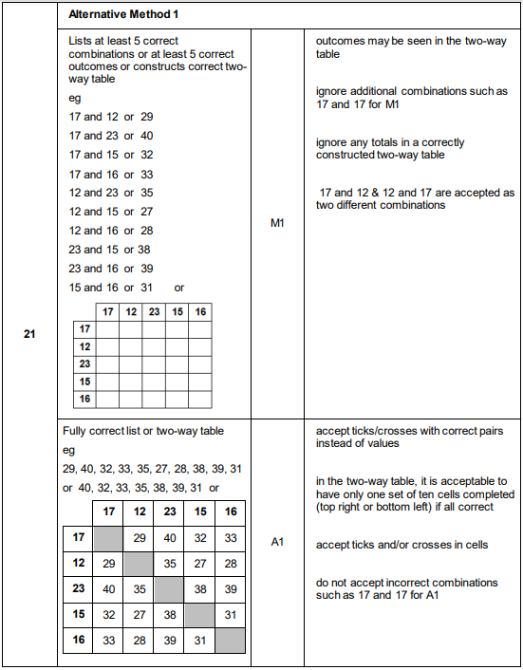

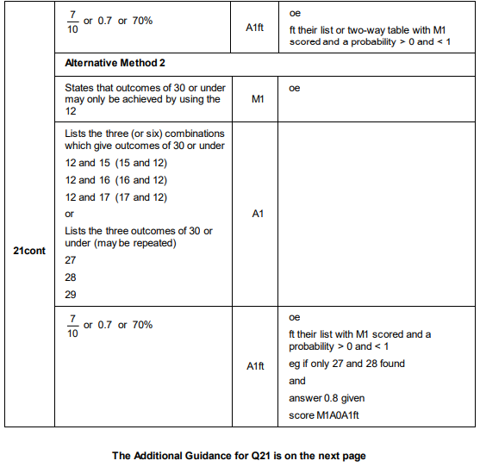
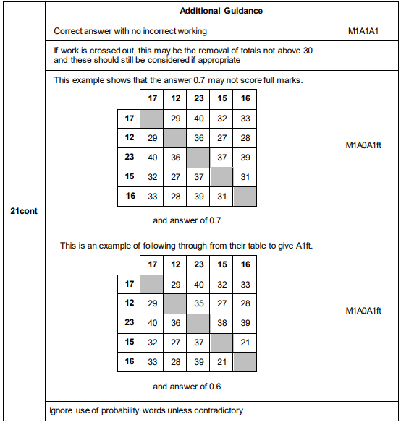

AQA Thursday 24 May 2018 – Morning (Non-Calculator) Foundation Tier

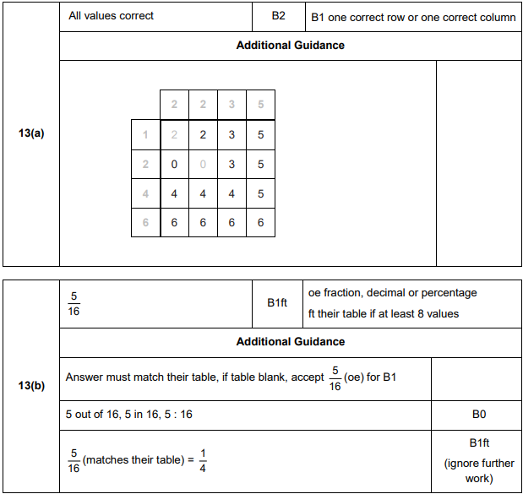
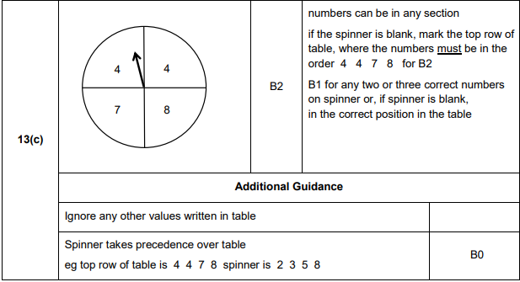
AQA Thursday 7 June 2018 – Morning (Calculator) Foundation Tier

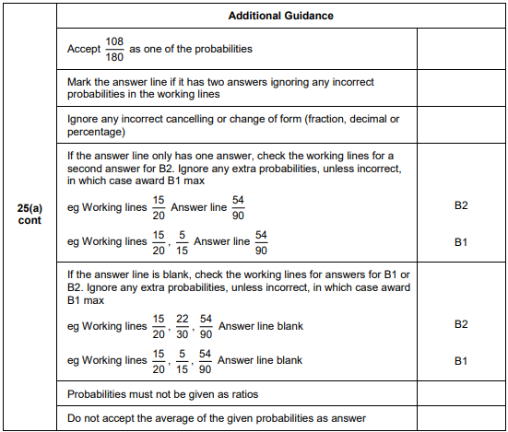
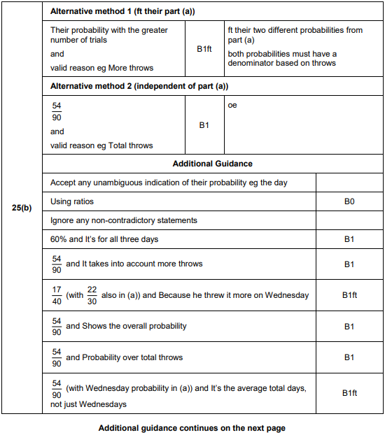
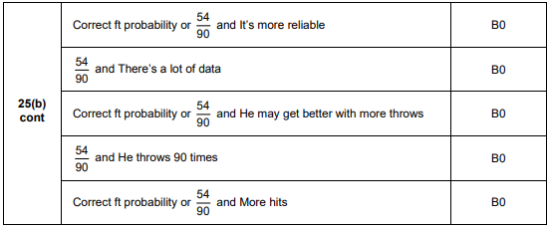
AQA Tuesday 12 June 2018 – Morning (Calculator) Foundation Tier

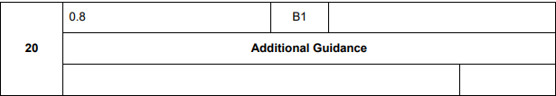
AQA Thursday 2 November 2017 – Morning (Non-Calculator) Foundation Tier

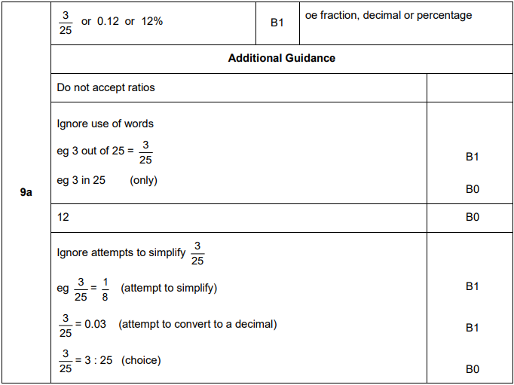
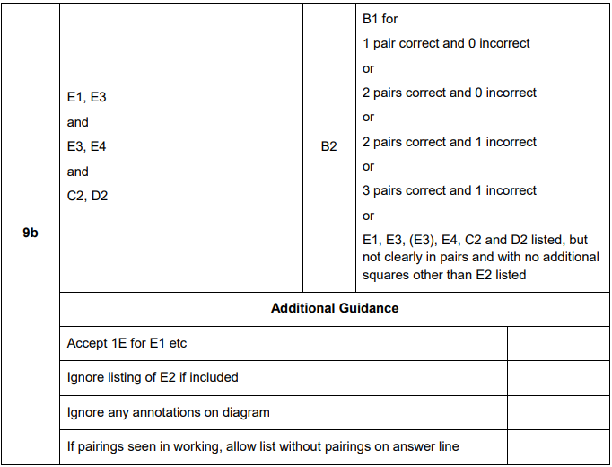
AQA Thursday 2 November 2017 – Morning (Non-Calculator) Foundation Tier

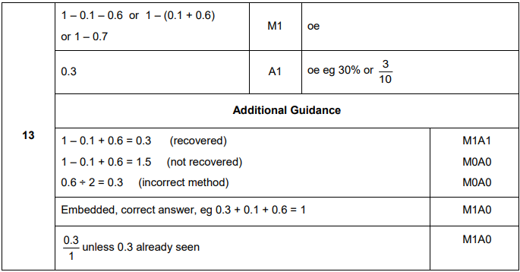
AQA Monday 6 November 2017 – Morning (Calculator) Foundation Tier

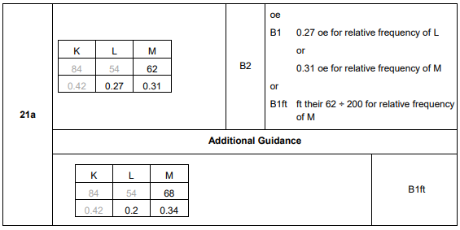
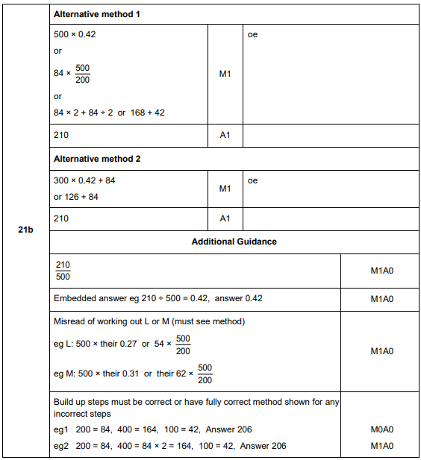
AQA Wednesday 8 November 2017 – Morning (Calculator) Foundation Tier

AQA Wednesday 8 November 2017 – Morning (Calculator) Foundation Tier

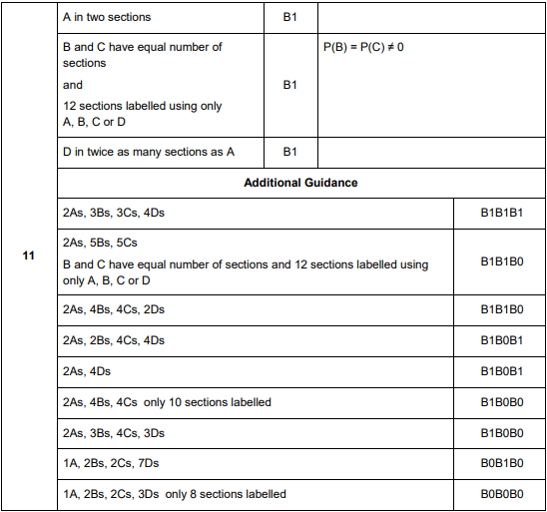
AQA Thursday 8 June 2017– Morning (Calculator) Foundation Tier

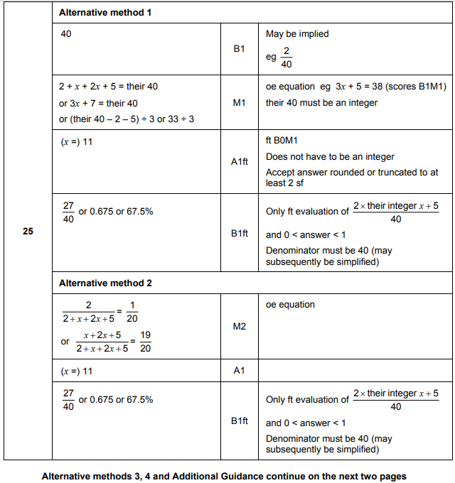
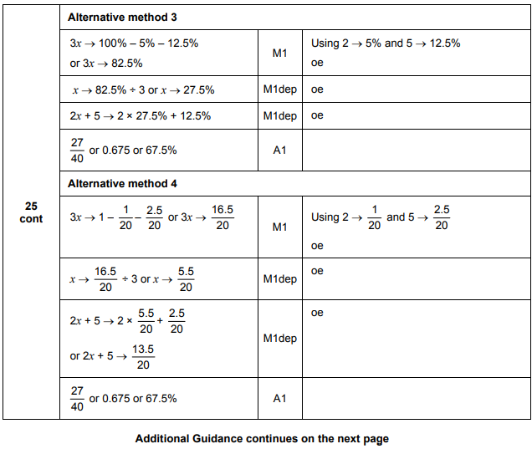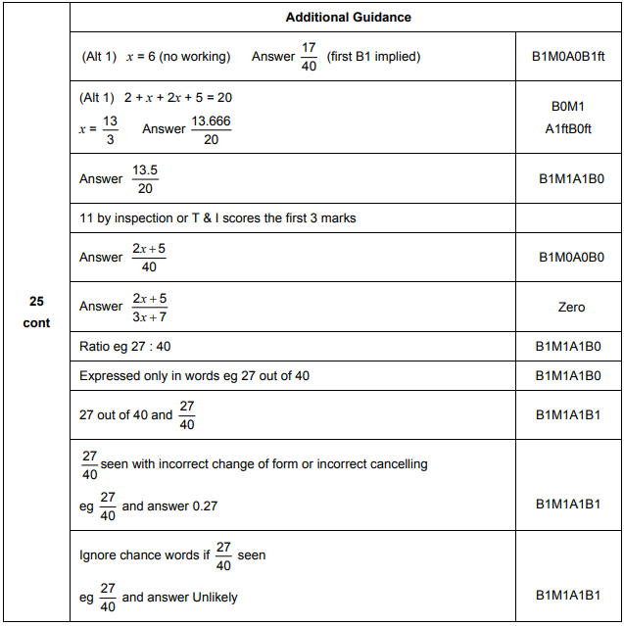

AQA Tuesday 13 June 2017 Morning– Morning (Calculator) Foundation Tier

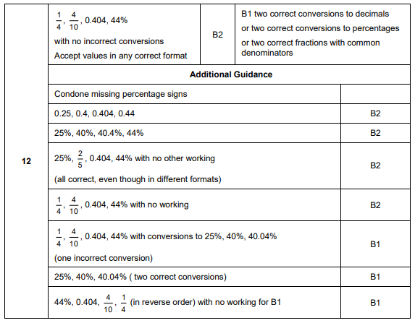

AQA Sample Paper 3– Morning (Calculator) Foundation Tier

